Multi-Line Insurance Policy and Claims Management System
Project Report · Arifa Institute of Technology · Team DEPSYNTEL
Team Role | Name
Team Lead | Hemadharshini M
Team Member | Priyadharshini M
Team Member | Suruthy S

Executive Summary
The Multi-Line Insurance Policy and Claims Management System is a Salesforce-based solution that centralizes the management of Vehicle, Property, and Life Insurance policies and claims. It replaces fragmented, manual processes with structured Salesforce objects, Record Types, Field Sets, Flows, Apex automation, Approval Processes, and Lightning Web Components (LWC).
Agents use a guided Screen Flow to quote policies. Apex calculates premiums from factors such as state and model year. When a claim is created, a Record-Triggered Flow identifies the policy type and routes the claim to the correct queue. Claims Adjusters work from an LWC Claims Dashboard, and high-value claims (above $50,000) pass through a two-step approval involving a Senior Adjuster and a Manager. Access is controlled with state-based sharing rules and role-specific Permission Sets.
Key Facts | Detail
Platform | Salesforce (Lightning Experience)
Insurance lines | Vehicle, Property, Life
Core objects | Policy__c, Claim__c, Contact, User
Automation | Screen Flow, Record-Triggered Flows, Approval Process, Apex
User interface | Lightning App Builder, LWC (claimsDashboardLwc, claimTileLwc)
High-value claim threshold | Claim Amount greater than $50,000
Security | Permission Sets and state-based Sharing Rules
Delivery model | Agile, 4 sprints of 6 days, 20 story points each

1. Introduction

1.1 Project Overview
The system gives insurance agents a flexible data model for creating and managing policies, while guided Screen Flows simplify quoting. The system validates policy information, and Apex automation calculates premiums based on state and model year. Once a claim is created, automation identifies the related policy type and routes the claim to the appropriate claims queue.
For claims adjusters, an LWC-based Claims Dashboard shows assigned claims, including claim number, policy type, policy holder, claim amount, approval status, and days open. High-value claims exceeding the defined threshold are processed through a structured approval workflow involving Senior Adjusters and Claims Managers. Security and access are managed using sharing rules and role-specific Permission Sets.

1.2 Purpose
The purpose of the system is to provide one Salesforce platform for managing Vehicle, Property, and Life Insurance policies and claims. It is designed to overcome legacy processes that make quoting, policy issuance, and claims handling manual, slow, and inconsistent.
The solution aims to:
- Standardize and accelerate policy quoting and issuance.
- Automate claim initiation and routing based on policy type and claim severity.
- Provide a 360-degree view of Customer, Policy, and Claim information.
- Support guided quoting through Screen Flows and automated premium calculation.
- Improve data accuracy through validation rules.
- Improve claims adjuster efficiency with an LWC-based dashboard.

1.3 Objectives
# | Objective | Outcome Measured By
1 | Centralize policy and claim data | One Salesforce org holding all three insurance lines
2 | Guide and standardize quoting | Auto Quoting Screen Flow creating draft policies
3 | Automate premium calculation | PremiumCalculator Apex populating the Premium field
4 | Route claims automatically | Claim owner set to the Auto, Property, or Life queue
5 | Control high-value claims | Approval Process triggered above $50,000
6 | Give adjusters visibility | LWC Claims Dashboard with filters
7 | Protect data | Permission Sets and state-based sharing rules

1.4 Scope
In scope: policy and claim data model; Auto quoting flow with VIN validation; premium calculation; claim routing; high-value claim approval; approver screen flow with quick action; adjuster dashboard; sharing rules and Permission Sets; Apex test class.
Out of scope for this release: external vehicle or property database integration, customer-facing portal, and AI-based assistance (see Future Scope).

2. Ideation Phase

2.1 Problem Statement
The problems faced by insurance agents, adjusters, and managers, and their root causes, are summarized below.
Problem Experienced | Root Cause
The process is manual, slow, and inconsistent | Legacy systems and processes are used for policy issuance
Different insurance lines need different information | Vehicle, Property, and Life policies require different fields and validations
Quoting requires multiple steps and manual processing | There is no unified quoting platform
Claim review and routing are largely manual | Claims processes are not centralized
Adjusters lack a focused view of their claims workload | Claim information is not easily available
Claims must be handled according to policy type and severity | Routing processes are complex
Approval needs multiple levels of review | High-value claims require a structured approval process
Manual processing causes delays | Policy and claims processes are not automated
Policy, claim, and customer information is scattered | There is no unified platform across processes and systems

2.2 Empathy Map Canvas
User persona: Insurance Claims Adjuster
Quadrant | Observations
Think & Feel | Concerned about claim delays and workload
Hear | Customer and team concerns about claim resolution
See | Multiple claims, policy details, and approval statuses
Say & Do | Reviews claims and follows up on approvals
Pain | Manual processing, complex routing, and limited visibility
Gain | Claims dashboard, automation, and faster approvals

2.3 Brainstorming and Idea Prioritization
Idea | Description | Assessment
Manual registers | Policy and claim information maintained manually | Error-prone, no automation or reporting
Spreadsheet tracking | Policies, claims, and approvals tracked in spreadsheets | Difficult to scale, no workflow or security
Standalone portal | Separate portal for policy and claim management | High build effort, limited reporting and automation
Salesforce CRM (selected) | Unified platform for policies, claims, automation, and reporting | Meets all requirements
Why Salesforce CRM was selected:
- Automation: quoting, premium calculation, claim routing, and approvals are automated.
- Scalability: supports Vehicle, Property, and Life Insurance and can grow to more lines.
- Real-time visibility: centralized view of customer, policy, and claim information.
- Unified platform: policy and claims processes live in one system.
- Improved efficiency: less manual processing and faster claim handling.

3. Requirement Analysis

3.1 Customer Journey Map
Stage | What Happens | Primary Actor
1. Insurance Inquiry | Customer asks about coverage | Customer, Agent
2. Policy Selection | Vehicle, Property, or Life product is chosen | Customer, Agent
3. Quote Request | Agent starts the guided quoting flow | Agent
4. Policy Information Capture | Holder, start date, state, VIN, and model year are entered | Agent
5. Premium Calculation | Apex computes the premium | System
6. Policy Issuance | Draft policy is created with premium | Agent
7. Claim Initiation | Claim record is created against a policy | Agent, Adjuster
8. Claim Routing | Claim is routed to the Auto, Property, or Life queue | System
9. Claim Review and Approval | Adjuster reviews; high-value claims go to approvers | Adjuster, Approvers
10. Claim Resolution | Claim status is updated to Approved or Rejected | Approver
11. Customer Confirmation | Customer is informed of the outcome | Agent
12. Reporting and Visibility | Dashboards and reports show claim data | Manager

3.2 Solution Requirements

Functional Requirements
ID | Requirement
FR-01 | Create and manage Insurance Policy records for Vehicle, Property, and Life Insurance
FR-02 | Support separate Record Types for Vehicle, Property, and Life policies
FR-03 | Capture product-specific information such as VIN for Vehicle and Square Footage and Year Built for Property
FR-04 | Provide a guided Auto Quoting Screen Flow capturing policy holder, start date, state, VIN, and model year
FR-05 | Create a draft policy during the quoting process
FR-06 | Calculate premiums using Apex-based logic
FR-07 | Validate that a Vehicle VIN contains exactly 17 characters
FR-08 | Create and manage Claim records associated with policies
FR-09 | Support Claim Record Types for Accident, Property, and Life claims
FR-10 | Route claims automatically to the correct queue based on policy type
FR-11 | Identify high-value claims using the configured amount threshold
FR-12 | Submit qualifying claims through a multi-level approval involving Senior Adjusters and Claims Managers
FR-13 | Provide Approve/Reject capability with approver comments
FR-14 | Provide Claims Adjusters an LWC Claims Dashboard of assigned claims
FR-15 | Display Claim Number, Policy Type, Policy Holder, Claim Amount, Status, and Days Open
FR-16 | Allow filtering by All, Auto, Property, and Life
FR-17 | Update related Policy and Claim records through Record-Triggered Flows
FR-18 | Support state-based access and sharing
FR-19 | Provide role-specific access via Permission Sets for Agents, Adjusters, and Managers
FR-20 | Support reporting on Customer, Policy, and Claim information

Non-Functional Requirements
Some of these are derived from the project's stated objectives rather than formally documented.
Category | Requirement
Usability | Simple, guided Screen Flows that minimize clicks and make quoting easy
Performance | Quoting, premium calculation, claim routing, and dashboard operations execute efficiently
Scalability | Supports three insurance lines and can accommodate additional products
Data quality | Policy and claim information is validated for accuracy and consistency
Security | Access is controlled by user responsibility, with state-based sharing and Permission Sets
Maintainability | Modular components (Flows, Apex, LWC, Record Types, Field Sets) allow easy change
Reliability | Routing, premium, and approval logic execute consistently per configured rules
Flexibility | One data model handles product-specific fields without separate structures per line
Information access | Users get timely access to Customer, Policy, and Claim data via records and the dashboard
User experience | Intuitive experience that reduces manual effort and supports adoption

3.3 Data Flow Diagram
Overall flow: Customer / Agent → Screen Flow → Policy Validation → Policy__c → PremiumCalculator → Claim__c → Claim Routing Flow → Claims Queue → Claims Adjuster → Approval Process → Claim Update → LWC Dashboard / Reports
Step | Name | Description
1 | Customer / Agent Input | The Insurance Agent provides customer and policy information
2 | Policy Data Capture | AutoQuoting Screen Flow captures holder, start date, state, VIN, and model year
3 | Policy Validation | Salesforce validates input, including the 17-character VIN rule
4 | Policy Creation | Valid data is stored in Policy__c with the right Record Type
5 | Premium Calculation | Policy data is passed to PremiumCalculator Apex
6 | Claim Creation | A Claim__c record is created and linked to a Policy
7 | Claim Routing | A Record-Triggered Flow routes the claim to the Auto, Property, or Life queue
8 | Claim Review | The adjuster reviews claims through the dashboard
9 | High-Value Approval | Claims above the threshold go to Senior Adjuster, then Claims Manager
10 | Decision and Update | Approver selects Approve or Reject with comments; status updates
11 | Dashboard and Reporting | Claim data appears in the LWC dashboard and reports

3.4 Technology Stack
Layer | Technology
UI | Salesforce Lightning, Lightning Web Components
Logic | Salesforce Flows, Apex
Database | Custom Objects (Policy__c, Claim__c), Contact, User
Automation | Record-Triggered Flows, Validation Rules, Approval Processes
Processing | Apex Premium Calculator, Apex Controllers
Data configuration | Record Types, Field Sets, Custom Fields
Security | Permission Sets, State-Based Sharing Rules
Reporting | Claims Dashboard, Reports and Dashboards
Testing | Apex Test Classes

4. Project Design Phase

4.1 Problem–Solution Fit
Salesforce fits this project because it addresses the key challenges through configurable automation, flexible data management, secure access, and real-time visibility. Screen Flows, Record Types, Field Sets, Apex, Record-Triggered Flows, Approval Processes, and LWC together support quoting, premium calculation, claim routing, approval, and adjuster operations.

4.2 Proposed Solution
Parameter | Description
Problem | Manual and inconsistent policy quoting, issuance, and claims handling
Solution | Salesforce CRM-based Insurance Policy and Claims Management System
Innovation | Automated quoting, premium calculation, claim routing, and high-value claim approval
Impact | Faster policy processing, efficient claim handling, improved customer service
Business model | Centralized management of Vehicle, Property, and Life Insurance
Scalability | Flexible data model supporting more products and future expansion
Visibility | Centralized Customer, Policy, and Claim information with Claims Dashboard
Security | Role-based and state-based access using Permission Sets and Sharing Rules

4.3 Solution Architecture
The system uses a layered Salesforce architecture covering quoting, premium calculation, claims processing, approvals, security, and reporting.
Layer | Project Implementation
User | Insurance Agents, Claims Adjusters, Claims Managers
UI | Salesforce Lightning, Screen Flows, LWC
Automation | Record-Triggered Flows, Approval Processes, Validation Rules
Business logic | Apex PremiumCalculator and ClaimsAdjusterController
Data | Policy and Claim custom objects with Vehicle, Property, and Life Record Types
Security | Permission Sets and state-based Sharing Rules
Reporting | Claims Dashboard, Reports, and Salesforce Dashboards

Architecture Diagram
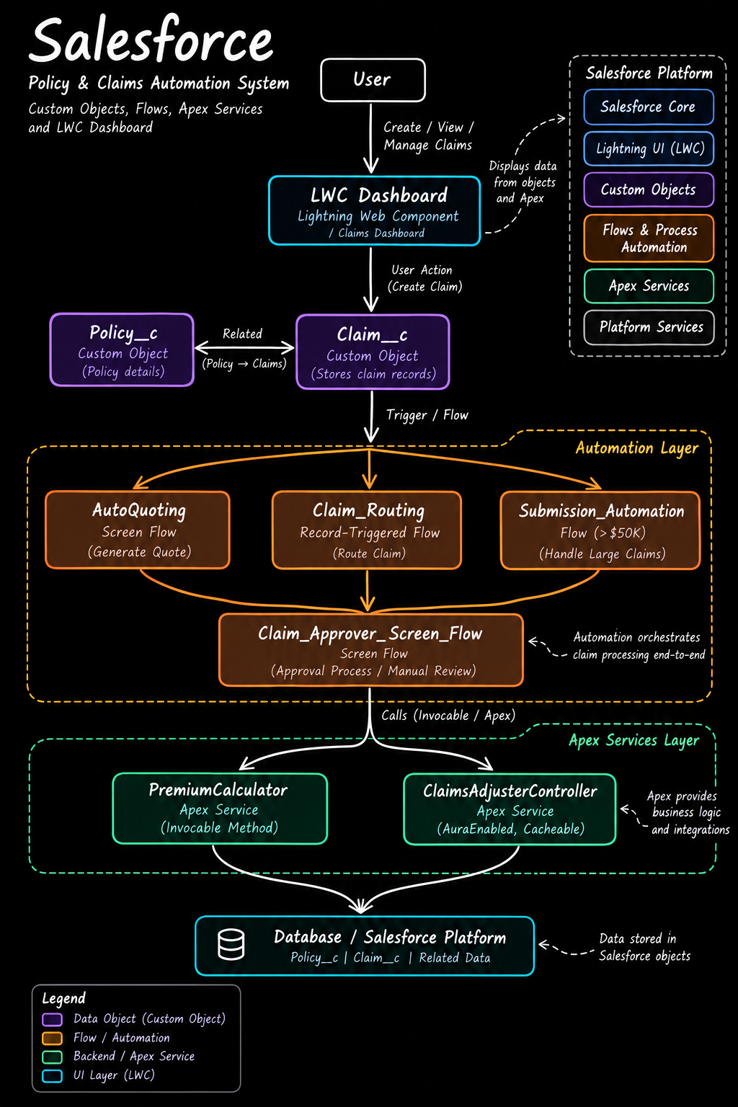
Figure 1: Salesforce Policy and Claims Automation System (custom objects, flows, Apex services, and LWC dashboard).

Diagram Explanation
The diagram reads from top to bottom. A user works in the UI, which creates data, which triggers automation, which calls Apex business logic, which reads and writes the Salesforce database. The panel at the top right lists the Salesforce Platform building blocks the whole solution runs on.
Step-by-step walkthrough
Step | Diagram Element | What It Does
1 | User | The agent, adjuster, or manager who creates, views, and manages claims
2 | LWC Dashboard (Lightning Web Component / Claims Dashboard) | The entry point for users. It displays data from the objects and Apex (dashed line to the Salesforce Platform panel) and passes the user action "Create Claim" down the chain
3 | Claim__c (custom object) | Stores claim records. It is related to Policy__c (policy details) through the Policy → Claims relationship
4 | Trigger / Flow | Creating a claim triggers the automation layer
5 | Automation Layer | Three flows run: AutoQuoting (screen flow that generates a quote), Claim_Routing (record-triggered flow that routes the claim), and Submission_Automation (flow for claims above $50K that handles large claims)
6 | Claim_Approver_Screen_Flow | The three flows converge here. This screen flow supports the approval process and manual review
7 | Apex Services Layer | The flows call Apex through invocable methods. PremiumCalculator calculates premiums; ClaimsAdjusterController (AuraEnabled, cacheable) supplies claim data to the dashboard
8 | Database / Salesforce Platform | Both Apex services read and write the Policy__c, Claim__c, and related data stored in Salesforce objects
Layers in the diagram
Layer | Components | Role
UI Layer (cyan) | LWC Claims Dashboard | Shows claims and starts user actions
Data Objects (purple) | Policy__c, Claim__c | Hold policy and claim records and their relationship
Automation Layer (orange, dashed box) | AutoQuoting, Claim_Routing, Submission_Automation, Claim_Approver_Screen_Flow | Orchestrates claim processing end to end
Apex Services Layer (green, dashed box) | PremiumCalculator, ClaimsAdjusterController | Provides business logic and integrations
Database / Platform (cyan) | Policy__c, Claim__c, related data | Stores all data in Salesforce objects
Salesforce Platform panel (top right)
Block | Meaning
Salesforce Core | The underlying CRM platform
Lightning UI (LWC) | Front-end components such as the Claims Dashboard and claim tile
Custom Objects | Policy__c and Claim__c
Flows and Process Automation | Screen flows, record-triggered flows, and the approval process
Apex Services | PremiumCalculator and ClaimsAdjusterController
Platform Services | Security, sharing, and Permission Sets that protect the data
Legend: purple marks data objects (custom objects), orange marks flows and automation, green marks backend Apex services, and cyan marks the UI layer (LWC).
How the diagram maps to the build: the diagram shows the system at a high level. In the build, AutoQuotingFlow calls PremiumCalculator to price a draft policy (Milestone 2), Claim_Routing_Flow assigns each new claim to the Auto, Property, or Life queue, and the Submission Automation Flow sends claims above $50,000 into the High Value Claim Approval process. Approvers then use the Claim Approver Screen Flow from a quick action on the claim record (Milestone 4).

4.4 Data Model Summary
Policy__c (record name: Policy Number, auto number format P-{0000})
Field | Data Type | Used For
Customer | Lookup (Contact) | Policy holder
Policy Start Date | Date | All policies
Policy State | Picklist | Premium calculation, state sharing
Premium | Currency (16,2) | Calculated by Apex
VIN | Text (20) | Vehicle policies
Model Year | Text (5) | Vehicle policies
Square Footage | Number (18,0) | Property policies
Year Built | Text (5) | Property policies
Beneficiary Name | Text (50) | Life policies
Policy Term Months | Number (18,0) | Life policies
Claim__c (record name: Claim Number, auto number format C-{0000})
Field | Data Type | Notes
Policy | Lookup (Policy) | Links the claim to its policy
Adjuster | Lookup (User) | Assigned adjuster
Claim Amount | Currency (16,2) | Drives the approval threshold
Date of Loss | Date/Time | Used to compute days open
Description | Long Text Area | Claim narrative
Approval Status | Picklist | New, Submitted for Approval, Approved, Rejected
Record Types and Field Sets
Object | Record Types | Field Sets
Policy__c | Auto (Vehicle), Property, Life | Vehicle (VIN, Model Year); Property (Square Footage, Year Built); Life (Beneficiary Name, Policy Term Months)
Claim__c | Accident, Property, Life | None specified

5. Project Planning and Scheduling

5.1 Methodology
The project followed Agile: epics were broken into stories and sized in story points, work ran in fixed sprints, and velocity from completed sprints was used for estimation.

5.2 Product Backlog
# | User Story
1 | As an admin, I want to create Policy and Claim objects so policy and claim information can be stored and managed
2 | As an admin, I want to configure Vehicle, Property, and Life Record Types so different products can be managed in one model
3 | As an admin, I want to configure Field Sets and product-specific fields so diverse insurance information can be captured efficiently
4 | As an agent, I want a guided Auto Quoting Screen Flow so I can capture policy information in a standardized way
5 | As an agent, I want VIN validation during quoting so incorrect vehicle information is prevented
6 | As the system, I want PremiumCalculator Apex to calculate premiums so values are generated accurately
7 | As an agent, I want premium calculation integrated with the quoting Flow so the premium is available during quoting
8 | As a claims manager, I want claims routed by policy type so they reach the appropriate queue
9 | As an adjuster, I want a ClaimsAdjusterController so I can retrieve my assigned claims
10 | As an adjuster, I want a dashboard and reusable claim tile so I can manage assigned claims efficiently
11 | As a claims manager, I want high-value claims to go through an approval process and approver Flow
12 | As an administrator, I want tests, sharing rules, and Permission Sets so the solution is validated and users get appropriate access

5.3 Sprint Schedule and Velocity
Sprint | Duration | Start Date | Planned End Date | Story Points Planned
Sprint 1 | 6 days | 24 Oct 2024 | 29 Oct 2024 | 20
Sprint 2 | 6 days | 31 Oct 2024 | 05 Nov 2024 | 20
Sprint 3 | 6 days | 07 Nov 2024 | 12 Nov 2024 | 20
Sprint 4 | 6 days | 14 Nov 2024 | 19 Nov 2024 | 20
Total | 24 days |  |  | 80
Average velocity is 20 story points per 6-day sprint, or about 3.3 points per day.

6. Project Development Phase
Development was delivered in four milestones covering data modelling, fields and relationships, Lightning App Builder, Record-Triggered Flows, and Apex.

Milestone 1: Core Data Model and Policy Configuration
1.1 Create the Policy object. In Setup → Object Manager → Create → Custom Object, use label Policy (plural Policies), record name Policy Number, data type Auto Number with format P-{0000} starting at 1. Enable Allow Reports, Activities, and Track Field History; set deployment status to Deployed and enable Allow Search.
1.2 Define Policy Record Types. On Policy__c, create record types Auto, Property, and Life. For each, add a description, check Active, make it available to all profiles, and keep the default page layout assignment.
1.3 Create Field Sets. On Policy__c, create Field Sets Vehicle (VIN, Model Year), Property (Square Footage, Year Built), and Life (Beneficiary Name, Policy Term Months).
1.4 Create Policy fields. Add the ten fields listed in the data model summary (section 4.4).
1.5 Create the Claim object. Create Claim (plural Claims) with record name Claim Number, Auto Number format C-{0000} starting at 1, with the same optional features and deployment settings as Policy.
1.6 Define Claim Record Types. Create Accident, Property, and Life record types using the same steps as for Policy.
1.7 Create Claim fields. Add Adjuster, Approval Status, Claim Amount, Date of Loss, Description, and Policy as listed in section 4.4.
1.8 Build the AutoQuoting Screen Flow.
Element | Type | Configuration
Get Vehicle RT ID | Get Records | Object Record Type; sObject Type Name = Policy__c AND Record Type Name = Auto
New Auto Policy Quote – Basic Information | Screen | Lookup for Policy Holder (Customer__c), Policy Start Date (Date), Policy State (picklist choice set from Policy State)
Vehicle-Specific Details | Screen | VIN (text) and Model year (text)
Create Draft Policy | Create Records | Maps Customer, Model Year, Policy Start Date, Policy State, RecordTypeId, and VIN; stores the new Id in varPolicyId (Text)
The flow is saved as AutoQuotingFlow and activated.
1.9 Create the VIN validation rule. On Policy__c, create an active rule named VIN_Must_Be_17_Characters.
Property | Value
Formula | AND( RecordType.DeveloperName = "Auto", LEN( VIN__c ) <> 17 )
Error message | The Vehicle Identification Number (VIN) must be exactly 17 characters long for Auto Policies.
Error location | Field: VIN

Milestone 2: Complex Policy Issuance and Claim Routing Automation
2.1 PremiumCalculator Apex class. An invocable class that accepts a list of policy Ids (via the PremiumInputWrapper inner class), queries VIN, Model Year, and Policy State, and returns a premium for each policy. The rules are:
Rule | Effect on Premium
Base premium | 1,000.00
Policy State = CA | Multiply by 1.15
Policy State = TX | Multiply by 1.05
Model Year earlier than 2018 | Add 100
Example: a 2015 vehicle in California gives 1,000 × 1.15 + 100 = 1,250.00.
2.2 Integrate the premium into the flow. In AutoQuotingFlow, after Create Draft Policy add an action Calculate Premium Action that passes varPolicyId and returns varCalculatedPremium (Currency, 2 decimals). Then add an Update Records element, Update Policy With Premium, that finds the policy where Id equals varPolicyId and sets Premium to varCalculatedPremium. Save as a new version and activate.
2.3 Claim routing flow (Claim_Routing_Flow). An after-save Record-Triggered Flow on Claim, running when a record is created and optimized for Actions and Related Records.
Element | Type | Configuration
Get_Policy_RT | Get Records | Policy where Id equals the triggering Claim's Policy; first record only; Record Type stored in varPolicyRTName (Text)
Route by Policy Type | Decision | Outcome Auto Claim Route (varPolicyRTName = Auto); Outcome Property Claim Route (= Property); default Life Claim Route
Assign to Auto Queue | Update Records | Sets Claim OwnerId to the Auto queue Id
Assign to Property Queue | Update Records | Sets Claim OwnerId to the Property queue Id
Assign to Life Queue | Update Records | Sets Claim OwnerId to the Life queue Id

Milestone 3: Claims Adjuster LWC Dashboard Development
3.1 ClaimsAdjusterController (Apex). The cacheable @AuraEnabled method getAssignedClaims() queries all Claim__c records owned by the logged-in user (OwnerId = UserInfo.getUserId()), ordered by Date of Loss descending. It joins related Policy, Policy Record Type, and Customer (Contact) data and returns a list of ClaimWrapper objects.
ClaimWrapper Field | Source
claimId | Claim Id
claimNumber | Claim Name
claimAmount | Claim Amount
status | Approval Status
policyType | Policy Record Type Name ("Unknown" if missing)
policyHolderName | Customer Contact Name
daysOpen | Calculated from Date of Loss
3.2 claimsDashboardLwc. The dashboard component uses the Apex method through @wire and applies client-side filtering (All, Auto, Property, Life). Created through the Lightning Studio extension, exposed (isExposed) for Lightning App Page, Home Page, and Record Page targets. HTML, JavaScript, and meta-xml code is stored in the project repository.
3.3 claimTileLwc. A reusable tile that shows the essential details of each claim, created and exposed with the same targets as the dashboard.

Milestone 4: Advanced Claim Processing, Security, and Code Setup
4.1 Approval Status field. Picklist on Claim with values New, Submitted for Approval, Approved, and Rejected.
4.2 High Value Claim Approval process.
Setting | Value
Object | Claim
Setup type | Standard setup wizard
Entry criteria | Claim Amount greater than 50,000
Record editability | Administrators only during approval
Approval page fields | Claim Number, Owner, Claim Amount, Adjuster, Policy
Security | Approvers access the page only from within Salesforce
Initial submitters | Claim owner

Approval Step | Approver | Multiple-Approver Rule | Reject Behaviour
Step 1: Senior Adjuster | Senior Adjuster user | First response decides | Default
Step 2: Manager Review | Department Manager user | First response decides | Perform all rejection actions for this step and all final rejection actions

Action Stage | Field Update | Approval Status Becomes
Initial submission | Update Status Submitted | Submitted for Approval
Final approval | Update Status Approved | Approved
Final rejection | Update Status Rejected | Rejected
4.3 Submission Automation Flow. An after-save Record-Triggered Flow on Claim, triggered on create or update when Claim Amount > 50,000 and Approval Status = New. It runs every time a record is updated and meets the criteria. A single action, Submit Claim to Approval, passes the triggering Claim Id and the approval process name High Value Claim Approval.
4.4 Claim Approver Screen Flow.
Element | Type | Configuration
recordId | Variable (Text) | Available for input
Get Claim Details | Get Records | Claim where Id equals recordId; all fields stored
Claim Review Screen | Screen | Displays Claim ID, Amount, and Policy Type; radio buttons Approve/Reject; long text field Approver Comments
Check Decision | Decision | Outcome Decision Approved; default Decision Rejected
Approve Claim | Action | Submit for approval with recordId and approver comments
Reject Claim | Action | Submit for approval with recordId and approver comments
A quick action named Approve/Reject Claim (Action Type: Flow) is added to the Claim page layout under Mobile and Lightning Actions. The flow is saved as Claim Approver Screen Flow.
4.5 Apex test class. ClaimsAdjusterControllerTest covers claim retrieval and filtering logic with a target of at least 95% code coverage. Run it from Developer Console using Run Test and review coverage under the Tests tab.
4.6 State-based sharing rules. Under Sharing Settings for the Claim object, create criteria-based rules such as Share Records based on Policy State CA, with Policy Account Holder State equal to the state, Read/Write access. Repeat for TX, NY, FL, and Other states.
4.7 Permission Sets.
Capability | Insurance Agent Access | Claims Adjuster Access | Claims Manager Access
Policy object | Create, Read | Read | Read
Claim object | Read | Read, Edit | Read, Edit, Delete
Contact object | Read, Edit | Not specified | Read, Edit
System permissions | Flow User enabled | None specified | Run Reports, Manage Approvals
Apex class access | PremiumCalculator | ClaimsAdjusterController | None specified
Purpose | Quoting only | Claim handling | Reporting and approvals

7. Functional and Performance Testing
The validation of each feature should be recorded with Salesforce screenshots. The scenarios below define what was verified and the expected result.
# | Test Scenario | Expected Result
1 | Run AutoQuotingFlow with valid data | Draft policy created with Auto Record Type
2 | Enter a VIN that is not 17 characters | Validation error on the VIN field
3 | Quote a 2015 vehicle in CA | Premium of 1,250.00 saved on the policy
4 | Quote a 2020 vehicle in TX | Premium of 1,050.00 saved on the policy
5 | Create a claim on an Auto policy | Claim owner set to the Auto queue
6 | Create claims on Property and Life policies | Claims owned by the Property and Life queues
7 | Create a claim with amount above 50,000 | Approval submitted; status Submitted for Approval
8 | Approve at Step 1 and Step 2 | Status becomes Approved
9 | Reject at either step | Status becomes Rejected
10 | Open the Claims Dashboard as an adjuster | Only owned claims shown with correct fields
11 | Use the All, Auto, Property, and Life filters | List filters correctly
12 | Run ClaimsAdjusterControllerTest | Passes with at least 95% coverage
13 | Log in as each Permission Set role | Access matches the permission matrix

7.1 Implementation Screenshots
The screenshots below were captured from the Salesforce Developer Edition org and the GitHub repository. They are shown in build order: data model, automation flows, security, and source code. Each screenshot is followed by an explanation of what it proves.

A. Data Model
Figure 2: Policy object fields
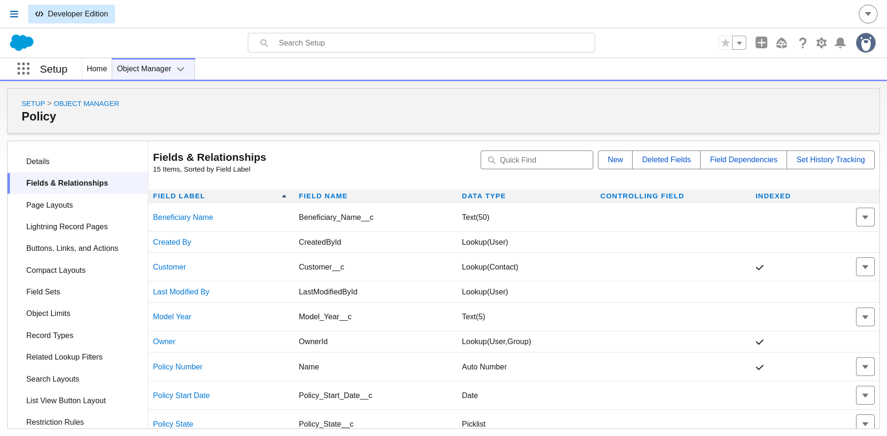
Setup → Object Manager → Policy → Fields & Relationships.
The Policy object lists 15 items. Visible fields include Beneficiary Name (Text 50), Customer (Lookup to Contact, indexed), Model Year (Text 5), Policy Number (Auto Number, the record name), Policy Start Date (Date), and Policy State (Picklist), along with standard fields such as Created By, Last Modified By, and Owner. The remaining custom fields (Policy Term Months, Premium, Square Footage, VIN, Year Built) sit below the visible area. This confirms that one object holds the product-specific fields for Vehicle, Property, and Life policies.
Figure 3: Claim object fields
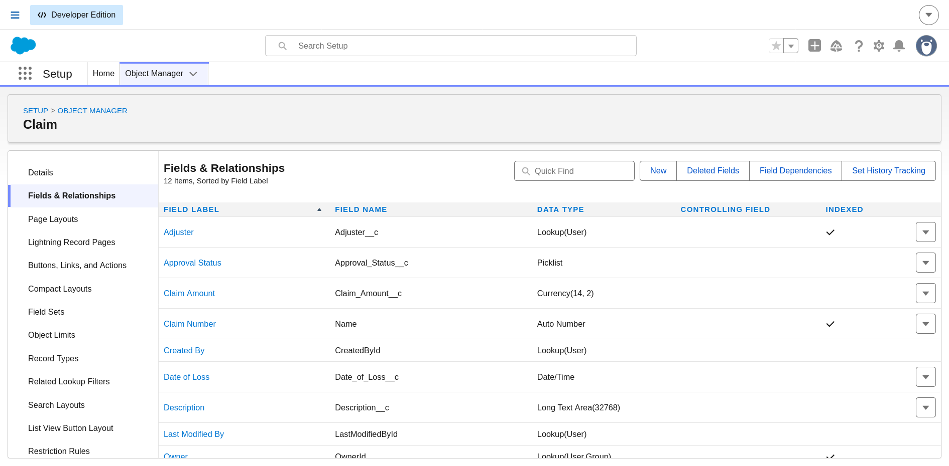
Setup → Object Manager → Claim → Fields & Relationships.
The Claim object lists 12 items: Adjuster (Lookup to User, indexed), Approval Status (Picklist), Claim Amount (Currency 14,2), Claim Number (Auto Number), Date of Loss (Date/Time), and Description (Long Text Area, 32,768 characters), plus system fields. Owner is a Lookup to User or Group, which is what lets the routing flow assign a claim to a queue. Note that the org uses Currency(14,2) for Claim Amount, while the build steps in section 6 mention (16,2); both hold values well above the $50,000 approval threshold.

B. Automation Flows
Figure 4: AutoQuotingFlow (Version 2)
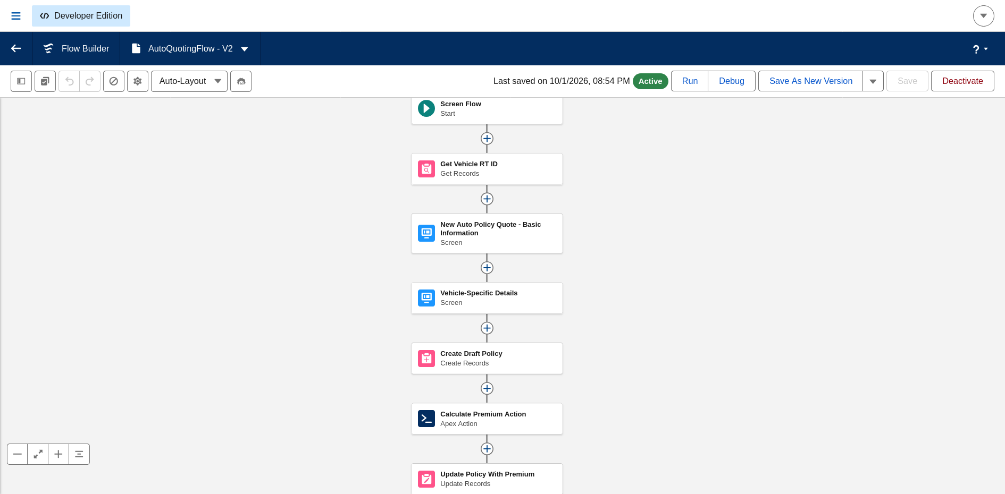
Flow Builder, status Active, last saved 10/1/2026 08:54 PM.
The Screen Flow runs in a straight line: Start → Get Vehicle RT ID (Get Records) → New Auto Policy Quote - Basic Information (Screen) → Vehicle-Specific Details (Screen) → Create Draft Policy (Create Records) → Calculate Premium Action (Apex Action) → Update Policy With Premium (Update Records). The Apex Action is the PremiumCalculator invocable method, and the last step writes its result to the Premium field. Version 2 is the version that includes the premium integration from Milestone 2.
Figure 5: ClaimRoutingFlow (Version 1)
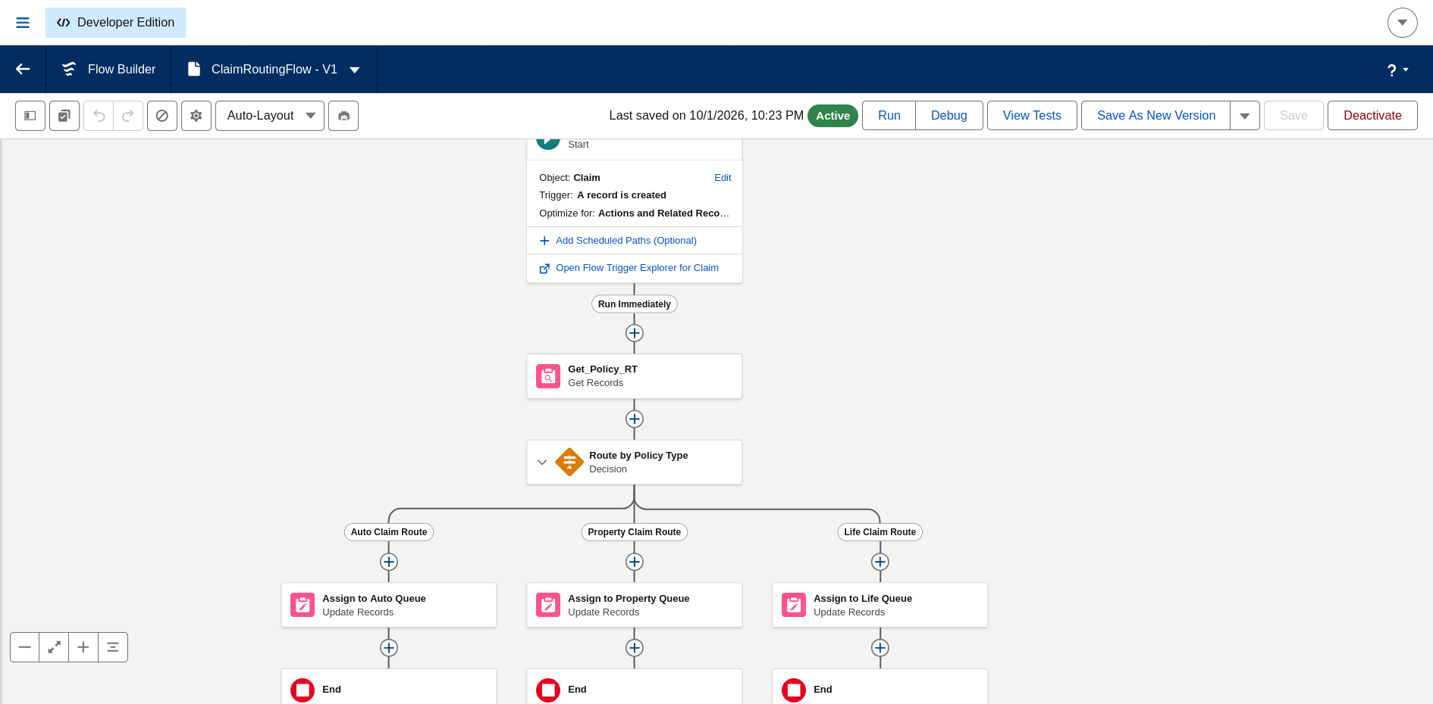
Flow Builder, status Active, last saved 10/1/2026 10:23 PM.
This record-triggered flow runs on the Claim object when a record is created and is optimized for Actions and Related Records. Get_Policy_RT retrieves the related policy, and the Route by Policy Type decision splits into three paths: Auto Claim Route, Property Claim Route, and Life Claim Route. Each path has an Update Records element (Assign to Auto Queue, Assign to Property Queue, Assign to Life Queue) that sets the claim owner, then ends. This is the claim routing described in Milestone 2.
Figure 6: Submission Automation Flow (Version 1)
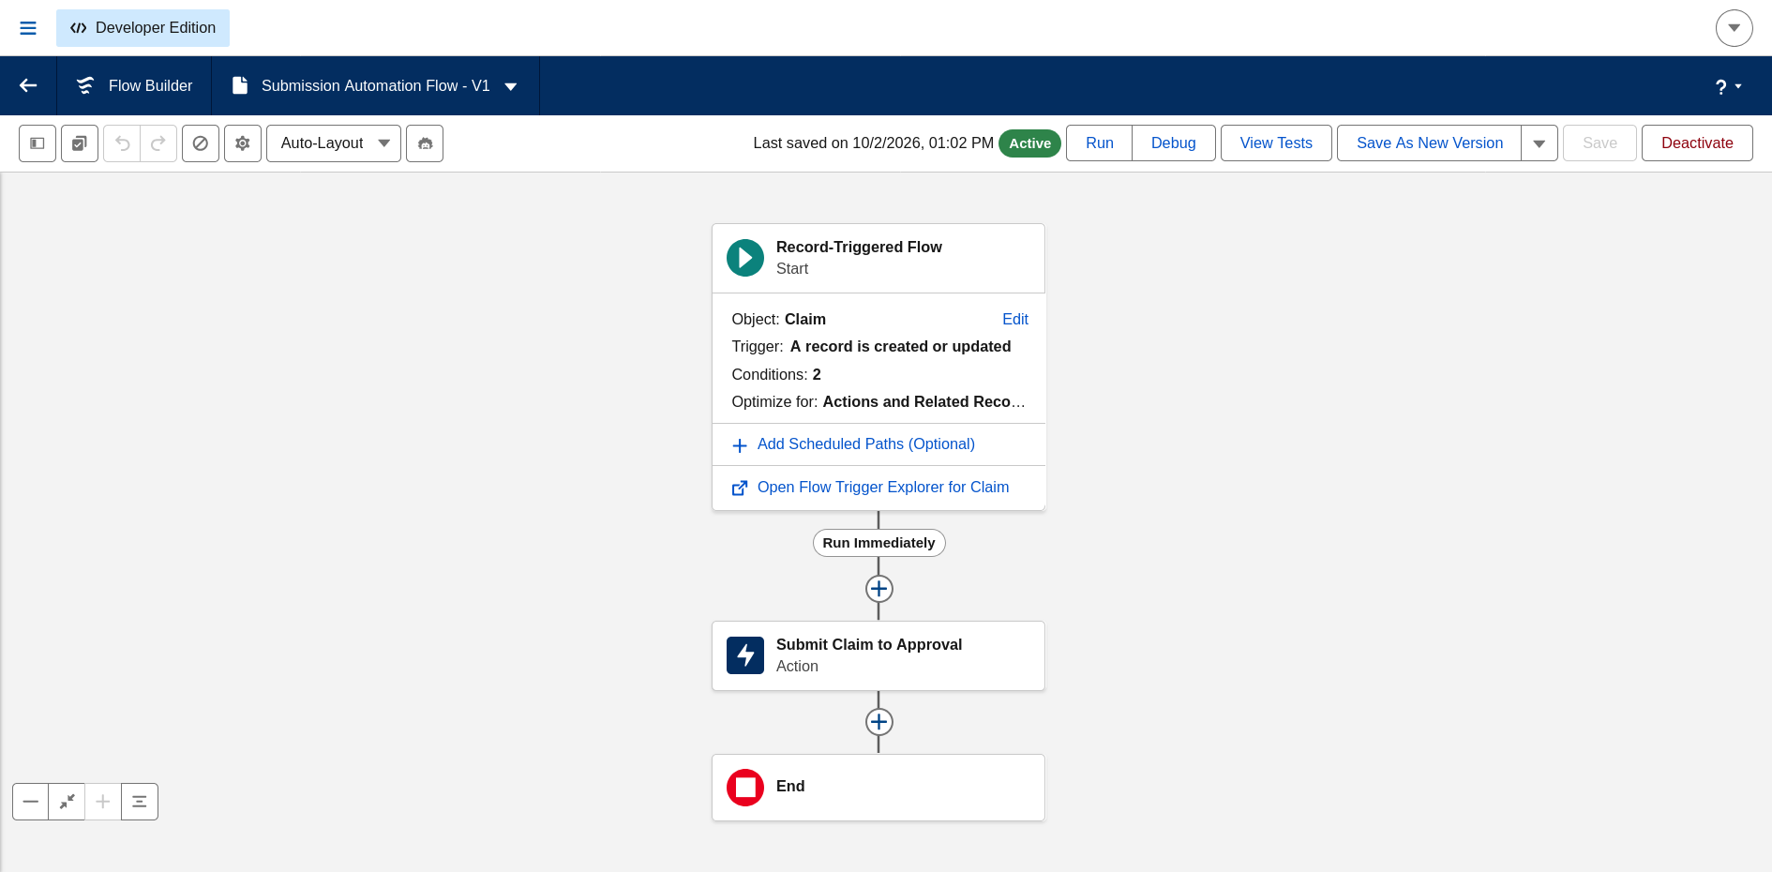
Flow Builder, status Active, last saved 10/2/2026 01:02 PM.
The start element shows Object: Claim, Trigger: A record is created or updated, Conditions: 2 (Claim Amount above 50,000 and Approval Status equal to New), and Optimize for: Actions and Related Records. The flow runs immediately and has one action, Submit Claim to Approval, which submits the claim to the High Value Claim Approval process before ending.
Figure 7: Flows list in Automation
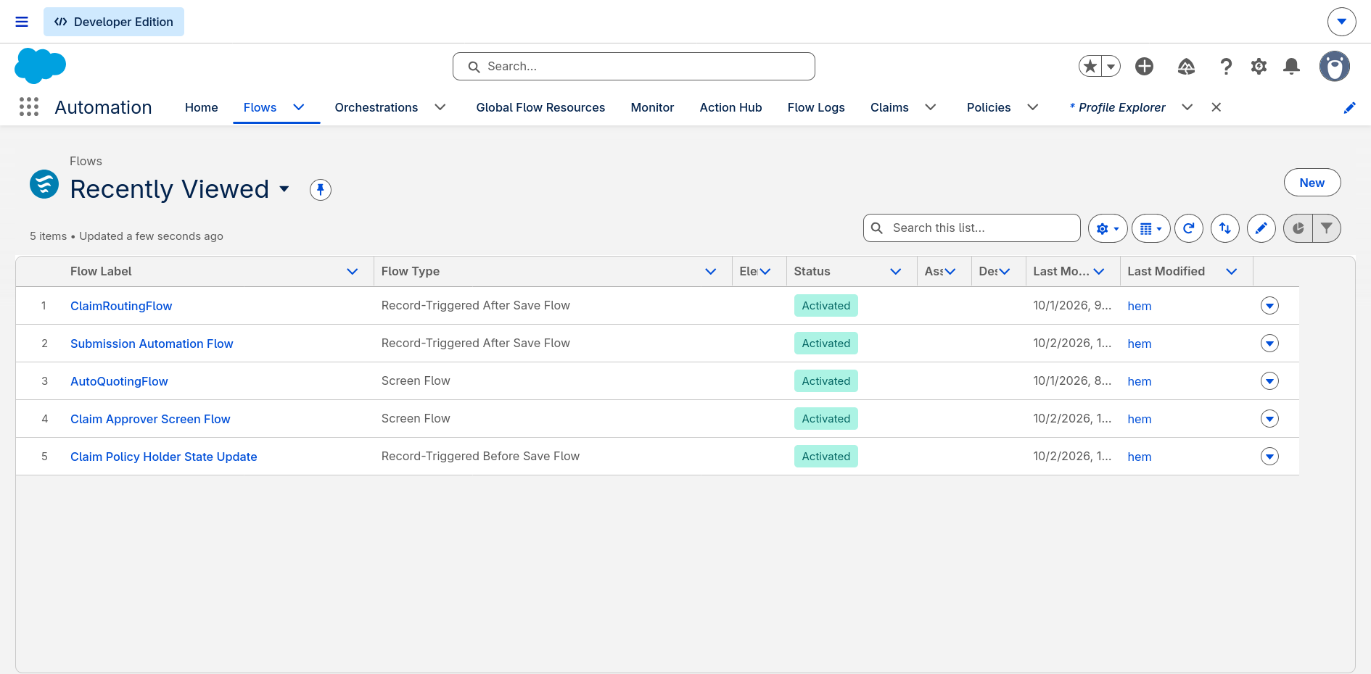
Automation app → Flows → Recently Viewed.
Five flows are shown and all have the status Activated:
Flow | Type
ClaimRoutingFlow | Record-Triggered After Save Flow
Submission Automation Flow | Record-Triggered After Save Flow
AutoQuotingFlow | Screen Flow
Claim Approver Screen Flow | Screen Flow
Claim Policy Holder State Update | Record-Triggered Before Save Flow
The fifth flow, Claim Policy Holder State Update, is a before-save flow that is not covered in the build steps. Given its name, it most likely copies the policy holder's state onto the claim so that the state-based sharing rules can use it. It is worth adding to section 6 so the documentation matches the org.

C. Security
Figure 8: Permission Sets page
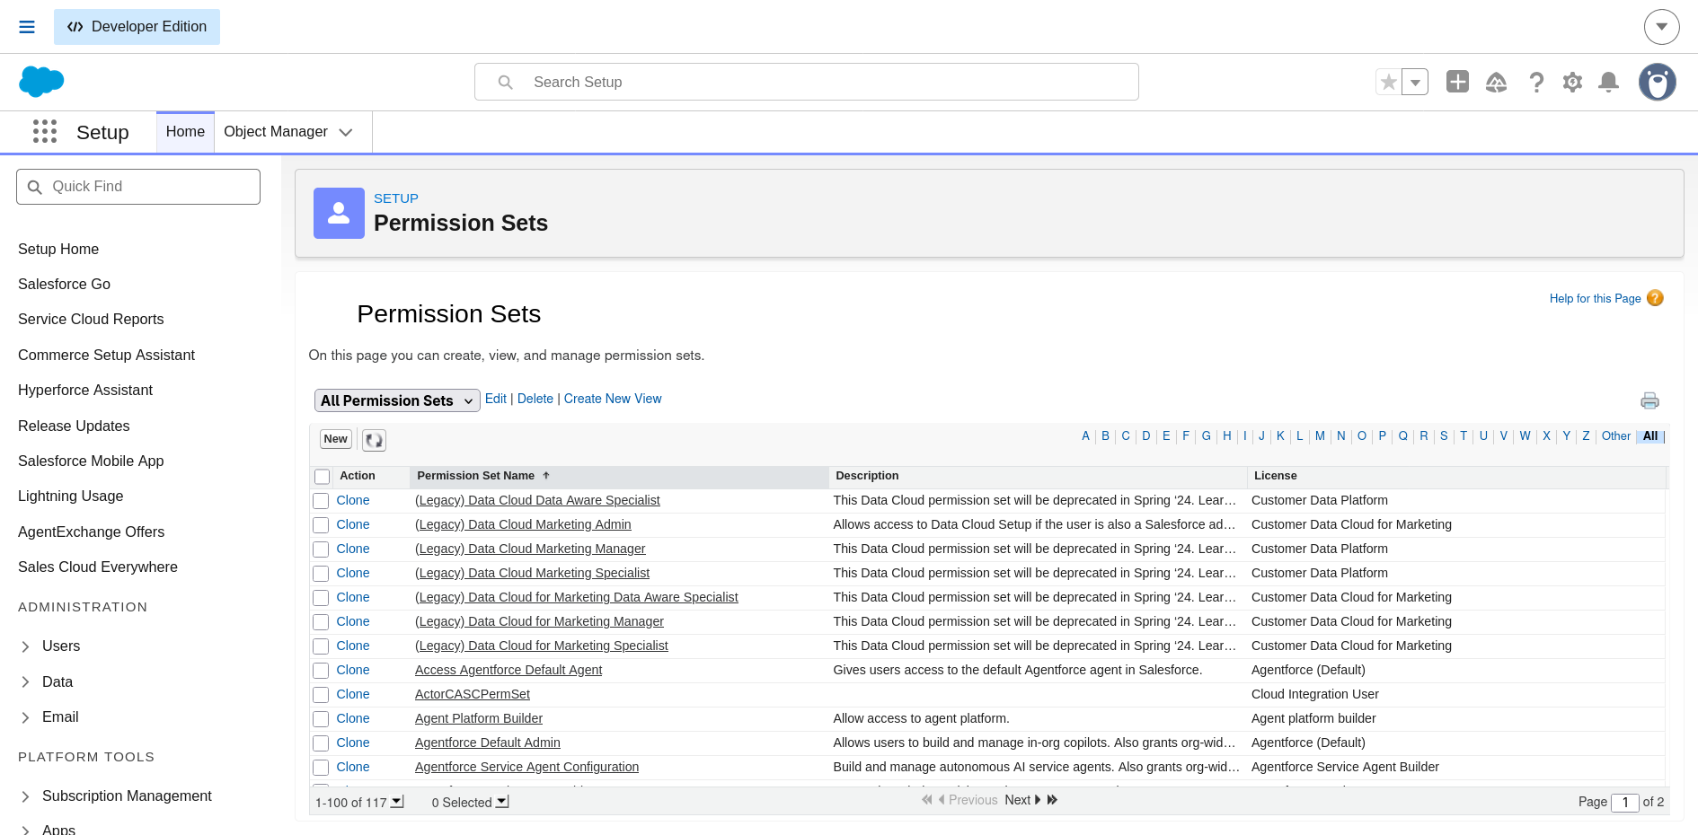
Setup → Permission Sets, All Permission Sets view (117 sets, page 1 of 2).
This is the page where the Insurance Agent Access, Claims Adjuster Access, and Claims Manager Access permission sets are created using the New button. The first page shows standard and legacy sets sorted alphabetically, so the three custom sets are further down the list. A follow-up screenshot of each set's Object Settings would be the strongest evidence of the permission matrix in section 6.
Figure 9: Sharing Settings page
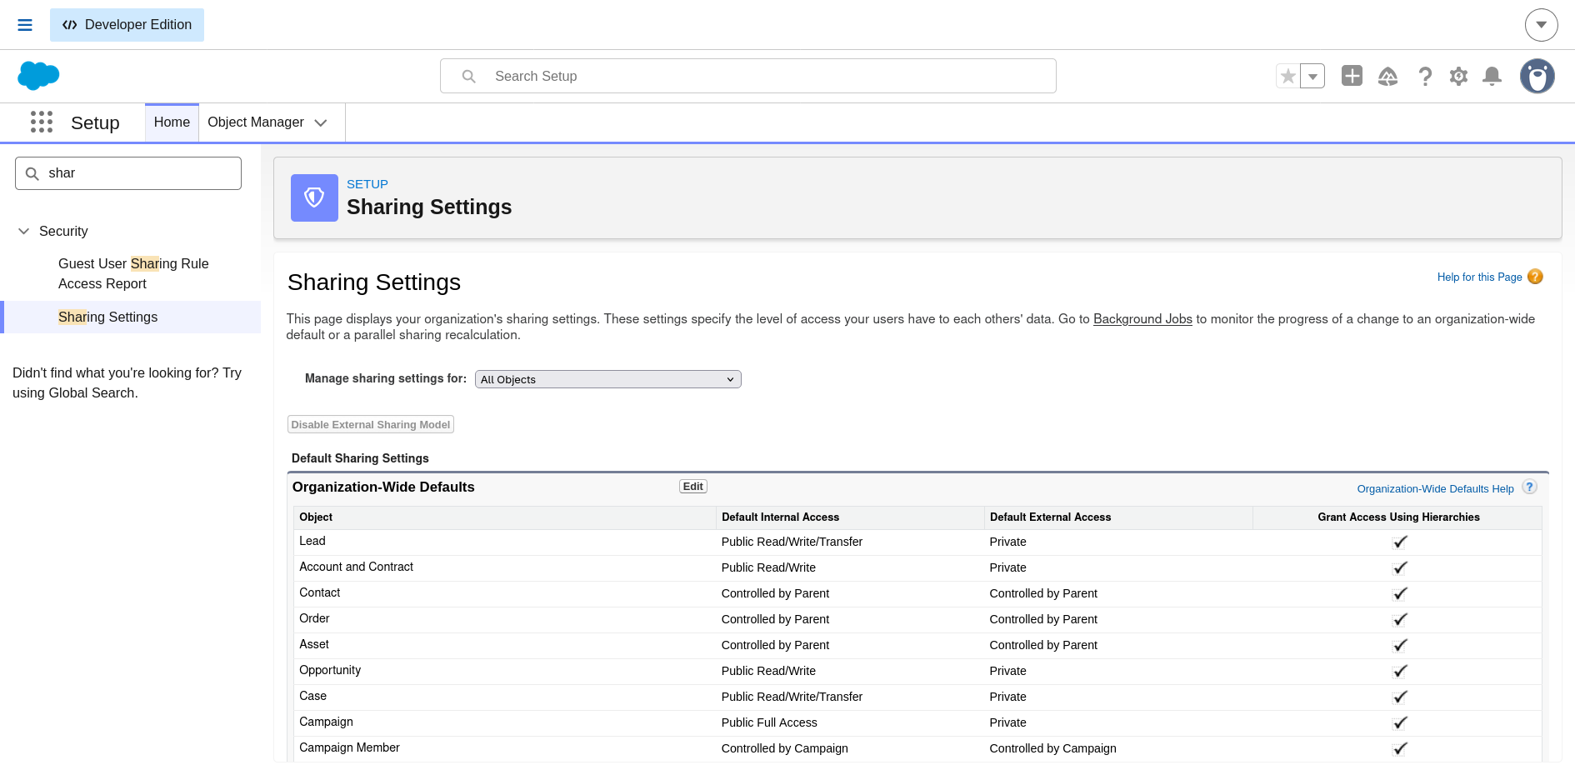
Setup → Sharing Settings, Manage sharing settings for: All Objects.
The Organization-Wide Defaults table is shown, with objects such as Lead (Public Read/Write/Transfer), Account and Contract (Public Read/Write), and Contact (Controlled by Parent). The Claim object's default access and its state-based sharing rules (CA, TX, NY, FL, Other) are further down this page, and can be shown by choosing Claim in the "Manage sharing settings for" dropdown.

D. Source Code Repository
Figure 10: GitHub repository
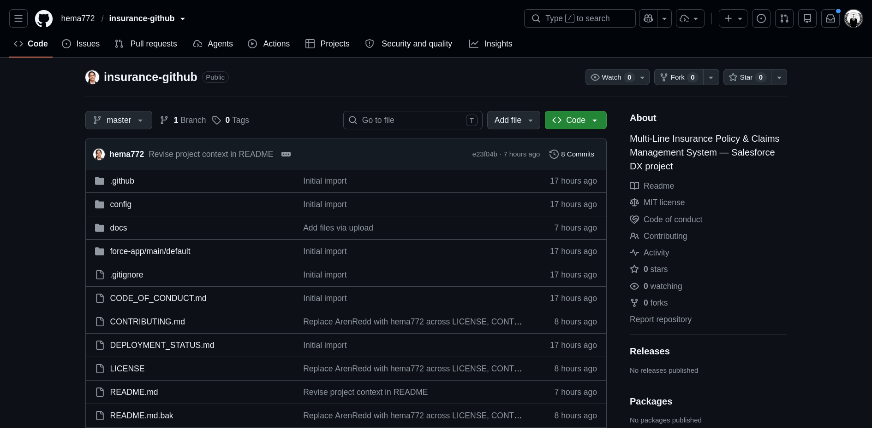
github.com/hema772/insurance-github (public).
The repository is described as "Multi-Line Insurance Policy & Claims Management System — Salesforce DX project". It has one branch (master), 8 commits, and an MIT license. The root contains the folders .github, config, docs (the architecture diagram), and force-app/main/default (the Salesforce metadata, including Apex and LWC), plus README.md, CONTRIBUTING.md, CODE_OF_CONDUCT.md, DEPLOYMENT_STATUS.md, and LICENSE. This is where the code referenced as "refer to repository" in Milestones 3 and 4 is stored.
Figure 11: README, Milestones 1 and 2
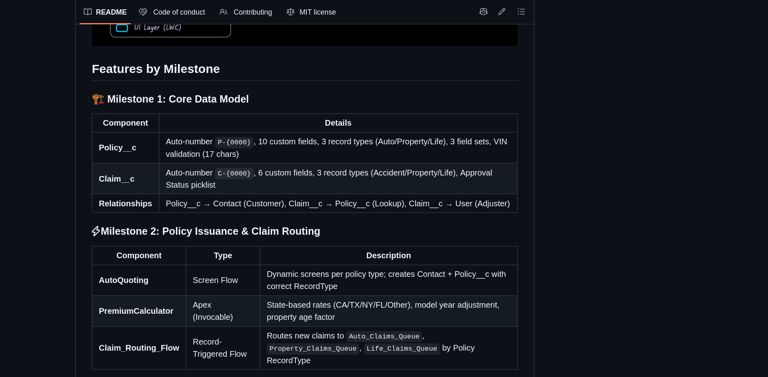
README → Features by Milestone.
Milestone | Component | Summary from the README
1 | Policy__c | Auto-number P-{0000}, 10 custom fields, 3 record types (Auto, Property, Life), 3 field sets, VIN validation (17 characters)
1 | Claim__c | Auto-number C-{0000}, 6 custom fields, 3 record types (Accident, Property, Life), Approval Status picklist
1 | Relationships | Policy__c to Contact (Customer), Claim__c to Policy__c (Lookup), Claim__c to User (Adjuster)
2 | AutoQuoting | Screen flow with dynamic screens per policy type; creates the Contact and Policy__c with the correct record type
2 | PremiumCalculator | Invocable Apex with state-based rates (CA, TX, NY, FL, Other), model year adjustment, and a property age factor
2 | Claim_Routing_Flow | Routes new claims to Auto_Claims_Queue, Property_Claims_Queue, or Life_Claims_Queue by policy record type
The README matches the data model and flow design in this report. One difference to check: the README describes PremiumCalculator with more states and a property age factor than the simpler version documented in section 6 (CA and TX rates plus a model year adjustment). Update whichever is out of date so both agree.
Figure 12: README, Milestones 3 and 4
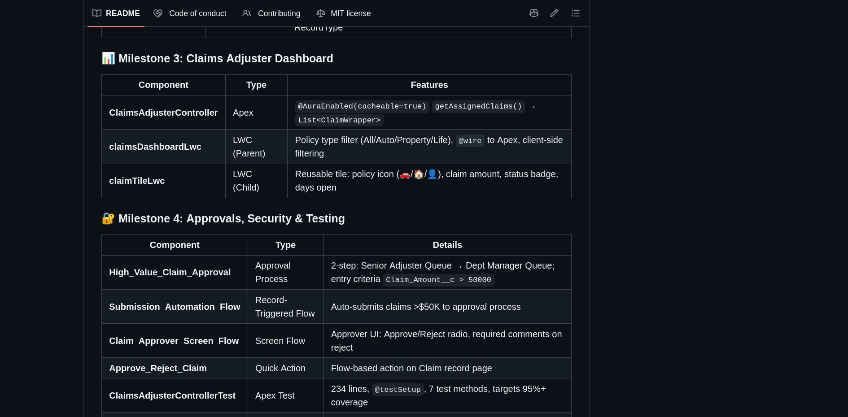
README → Features by Milestone (continued).
Milestone | Component | Summary from the README
3 | ClaimsAdjusterController | Apex, @AuraEnabled(cacheable=true) getAssignedClaims() returning List<ClaimWrapper>
3 | claimsDashboardLwc | Parent LWC with the All, Auto, Property, Life filter, @wire to Apex, and client-side filtering
3 | claimTileLwc | Child LWC tile showing a policy icon, claim amount, status badge, and days open
4 | High_Value_Claim_Approval | Two-step approval: Senior Adjuster Queue, then Dept Manager Queue; entry criteria Claim_Amount__c > 50000
4 | Submission_Automation_Flow | Record-triggered flow that auto-submits claims above $50K to the approval process
4 | Claim_Approver_Screen_Flow | Approver screen with Approve/Reject radio and required comments on reject
4 | Approve_Reject_Claim | Flow-based quick action on the Claim record page
4 | ClaimsAdjusterControllerTest | Apex test, 234 lines, @testSetup, 7 test methods, targets 95%+ coverage
This confirms the dashboard parent-child component design, the two-step approval, and the Apex test class. The README also states the Claim Approver Screen Flow requires comments on rejection, which is a small refinement over the build steps in section 6.

8. Advantages and Disadvantages

Advantages
Advantage | Description
Centralized platform | Vehicle, Property, and Life Insurance in one Salesforce system
Automated quoting | Screen Flows simplify and standardize quoting
Automated premium calculation | Apex calculates premiums consistently
Automated claim routing | Claims reach the right queue based on policy type
Faster claim processing | Approval and escalation reduce manual effort
Better visibility | LWC dashboard gives adjusters a focused view
Improved data accuracy | Validation rules keep policy data accurate
Flexible data model | Record Types and Field Sets support different products
Secure access | Permission Sets and Sharing Rules provide role- and state-based access
Scalable solution | Supports more lines and future enhancements

Disadvantages
Disadvantage | Description
Complex data management | Each policy line needs different data fields
Approval complexity | Approval must consider amount, policy type, and adjuster level
User adoption | Agents need intuitive flows to minimize clicks
Integration complexity | External database callout simulation needs extra Apex and mock test classes
Salesforce dependency | The solution relies on Salesforce configuration and platform capabilities
Implementation effort | Many flows, classes, components, and rules need careful maintenance

9. Observations and Recommendations
While consolidating the document, these items in the original design were noted for follow-up.
Area | Observation | Recommendation
Queue IDs | Claim routing hardcodes 18-digit queue Ids | Look up queues by developer name so the flow works across sandboxes and production
Days Open | The code uses Date.today().daysBetween(Date of Loss), which returns a negative number for past dates | Use Date of Loss.date().daysBetween(Date.today())
Policy State field | Premium logic and flow use Policy State, but it is missing from the original field list | Keep Policy State (picklist) in the Policy field table
Approver flow | Approve Claim and Reject Claim both use the submit-for-approval action | Use the approval action that processes the pending work item with Approve or Reject
Approval roles | The process names a "Department Manager" while the permission set is "Claims Manager" | Align role naming across documents
Record Type names | Policy uses Auto while the requirements say Vehicle | Standardize on one name
Testing section | Original text referred to dealers, stock, and orders from another project | Replaced here with insurance test scenarios; add real screenshots
Learning outcomes | Batch Apex and Scheduled Apex were listed but are not used | Remove, or add a scheduled stale-claim reminder job

10. Conclusion
The system provides a centralized Salesforce-based solution for managing Vehicle, Property, and Life Insurance policies and claims. It addresses the limitations of manual and fragmented processes through guided quoting, automated premium calculation, claim routing, structured approval, and an LWC-based Claims Dashboard.
By combining Flows, Apex, Record Types, Field Sets, Validation Rules, Approval Processes, LWC, Permission Sets, and Sharing Rules, the project improves policy processing, claim handling, data accuracy, security, and operational visibility. It shows how Salesforce can bring multiple insurance processes onto a single scalable platform.

11. Future Scope
Area | Enhancement
External system integration | Connect to external vehicle and property databases for real-time quote verification
Additional insurance products | Extend beyond Vehicle, Property, and Life
Advanced claims automation | Automated claim assessment and escalation based on claim characteristics
Enhanced analytics | Advanced dashboards and reports for policy, premium, and claims analysis
Customer experience | Customer-facing policy and claim status tracking
Mobile accessibility | Mobile access to key processes for agents and claims users
AI-based assistance | AI support for agents and adjusters
Advanced integration architecture | Expanded API-based integrations with insurance and verification systems

12. Appendix
Category | Items
Objects | Policy, Claim, Contact, User
Record Types | Vehicle (Auto), Property, Life; Accident, Property, Life
Automation | Screen Flows, Record-Triggered Flows, Approval Processes
Apex | PremiumCalculator, ClaimsAdjusterController
LWC | claimsDashboardLwc, claimTileLwc
Validation | 17-character VIN validation
Security | Permission Sets, State-Based Sharing Rules
Testing | ClaimsAdjusterControllerTest
Reporting | Claims Dashboard, Salesforce Reports and Dashboards

13. References and Links
- GitHub repository: https://github.com/hema772/insurance-github
- Demo link: Watch the project demo
- Architecture diagram: Salesforce Claims Automation Flowchart.png (docs/ folder of the repository)

